Miguel Ibrahim

Discrete Structures II in a nutshell for exam 1

# The Overview

In the normal day life, communicating with other people are done in languages, paragraphs, sentences, words, and letters.

The world of Computer Science is no different, we communicate to computers in their own language whether it is of Java, C++, C, SQL, R, and even the lowest language which is the assembly language.

This course covers how the computer interpret algorithms made for applications.

Every algorithm-based structure (Which isn’t many) can be converted by the machine into bits (a string of 1s and 0s), this algorithm is changed into what is known as DFAs and NFAs (Deterministic Finite Automata and Non-deterministic Finite Automata respectively).

# What is the language

We consider the language of a machine to be a string of bits there sings of bits can be all the known bits of a computer noted as sigma* (∑*), which is the whole language of a DFA.  
A language can look like this:

L=∑*

L= {0^i 1^j where i+j is odd} (An example for later)

All Languages that are not Sigma star fall under the subset of sigma star even if the language is infinite (not regular)

# What is a DFA

A Deterministic Finite Automata is a graph composed of nodes that defines the logical linear flow of a language.

A DFA for sigma star Can look like

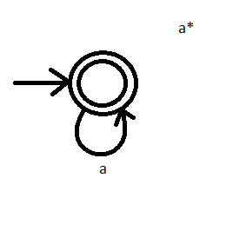Sigma star is composed of everything in the language and that includes infinite and nothing.

To make drawing a DFA easier you must know what string of bits exist in that language

For sigma star that is L= {e, 0, 1, 00, 01, 10, 11, 000, 001, 010, 011, etc.}

In DFAs things can become tree-like, huge, and extremely difficult.

L= {abcd where the 3rd node from the right is an a}

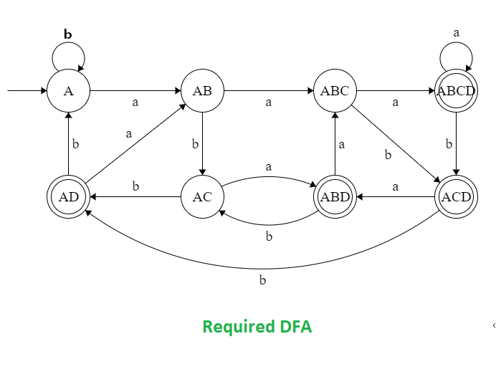However, all of this can be done in a much simpler manner.

# What is an NFA

Anything that can be done in a DFA can be done in an NFA and vice versa

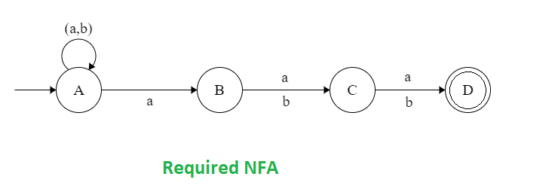

The idea for NFA is not the same for DFA, in an NFA the first node accepts anything while the rest read to one accepting state; however, if the strings Aaab leads to an accepting state and it still has a b, it is rejected from this configuration.

A string AAAB takes {A}🡪 {A, B}🡪{A, B, C}🡪{A, B, C, D}🡪{A, C, D}🡪😊

# Pumping Lemma